**Dataset**

The dataset comprises information on individuals with heart disease. It includes various values and metrics associated with patients diagnosed with heart-related conditions.

https://www.kaggle.com/datasets/rishidamarla/heart-disease-prediction

**Line Chart**

The line chart illustrates a correlation between aged blood pressure (BP) and heart rate (HR). As age increases, blood pressure peaks around 70, while heart rate decreases. Notably, at the age of 20, the heart rate is at 200 and gradually decreases to below 120 by age 80.

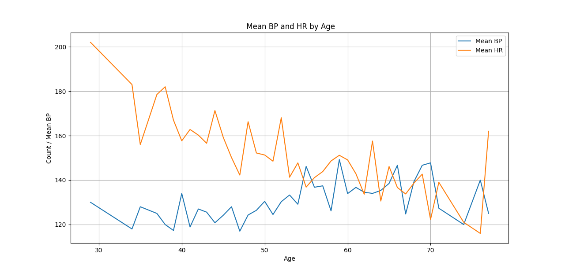

Figure 1 Heart Rate and Blood Pressure Analysis Against Age

**Pie Chart**

The pie chart visually represents the prevalence of heart issues within a research dataset. Notably, 56% of the participants exhibit an absence of heart disease, while 44.4% of the individuals manifest indications of heart-related conditions. This distribution provides insights into the distribution of heart health within the studied population, offering valuable information for further research and analysis.

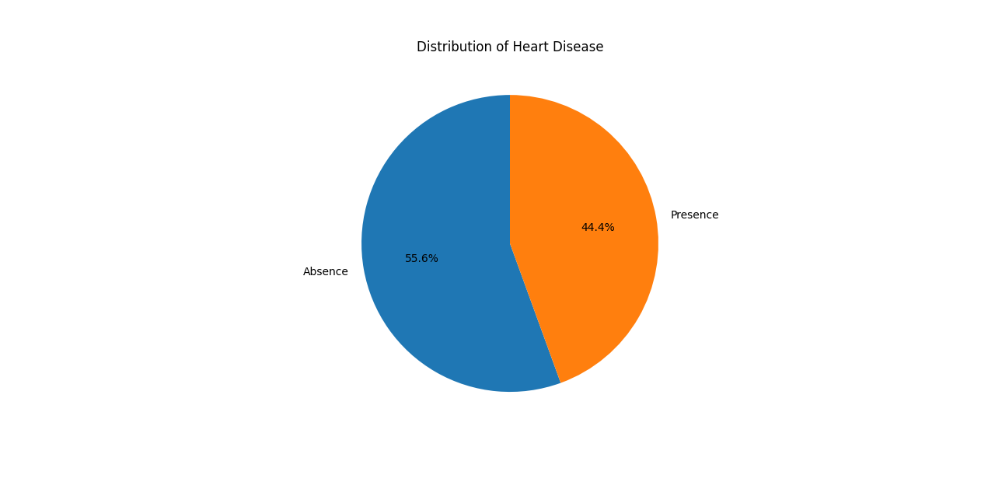

**Bar chart**

The bar chart illustrates the incidence of heart disease in both males and females. Notably, the data indicates a lower prevalence of heart disease in females, with 60 females displaying no signs of the condition, while only 20 females are identified with heart disease. In contrast, among males, 100 individuals are diagnosed with heart disease, while 80 males do not exhibit any indications of heart-related issues. The chart clearly compares the distribution of heart disease between the two genders.

